Midterm Exam STA 3920
PUT YOUR NAME HERE
Due March 28th of 2025
Table of Contents
Question 1 Prompt 1
Part A 2
Part B 2
Part C 3
Part D 5
Part E 6
Question 2 Prompt 9
Part A 10
Part B 10

Question 1 Prompt
The file valuation.csv (available on Brightspace1) contains market historical data of real estate valuation collected from Sindian Dist., New Taipei City, Taiwan. Our goal is to predict the per-unit-area house price using several important factors that can potentially affect buyers’ decision-making.
Features in the dataset:
- X₁: the transaction date (for example, 2013.250=2013 March, 2013.500=2013 June, etc.)
- X₂: the house age (unit: year)
- X₃: the distance to the nearest MRT station (unit: meter)
- X₄: the number of convenience stores in the living circle on foot (integer)
- X₅: the geographic coordinate, latitude. (unit: degree)
- X₆: the geographic coordinate, longitude. (unit: degree)
- Y: house price of unit area (10000 New Taiwan Dollar/Ping, where Ping is a local unit, 1 Ping = 3.3 square meters)

Part A
Load the dataset into R from valuation.csv. Split the dataset into training data (first 200 rows) and test data (the rest rows). Name the training and test data valuation_train and valuation_test, respectively. Where is the 11th house in the test data located (answer with the latitude and longitude)?
# Here I am importing the dataset locally stored
valuation <- read.csv("C:/Users/profz/Desktop/Midterm_Exam/valuation.csv")
# Here I am splitting it into training and test sets
valuation_train <- valuation[1:200, ]
valuation_test <- valuation[201:nrow(valuation), ]
# Here I am retrieving the 11th row from X5 and X6 variables
valuation_test[11, c("X5", "X6")]
## X5 X6
## 211 24.97937 121.5425
ANSWER: As observed, the 11th house in the test dataset is at X = 24.97937 and Y = 121.5425.

Part B
Use the training data valuation_train to fit a simple linear regression model of Y on X₂. Interpret the coefficients β₀ (intercept) and β₁ (slope) in terms of the real context. Compute R², training MSE and test MSE.
# Here I am fitting a regression model of Y on X2 using valuation_train
model <- lm(Y ~ X2, data = valuation_train)
# Here I am summarizing the model to extract coefficients and R-squared
summary_model <- summary(model)
beta0 <- coef(model)[1] # Intercept (β0)
beta1 <- coef(model)[2] # Slope (β1)
r_squared <- summary_model$r.squared # R-squared
# Here I am computing training MSE
train_predictions <- predict(model, valuation_train)
train_MSE <- mean((valuation_train$Y - train_predictions)^2)
# Here I am computing test MSE
test_predictions <- predict(model, valuation_test)
test_MSE <- mean((valuation_test$Y - test_predictions)^2)
# Here I show the output results
cat("\nMODEL METRICS\n",
"-> Intercept (β0):", beta0,
"\n -> Slope (β1):", beta1,
"\n -> R-squared:", r_squared,
"\n -> Training MSE:", train_MSE,
"\n -> Test MSE:", test_MSE,"\n")
## MODEL METRICS
## -> Intercept (β0): 44.46714
## -> Slope (β1): -0.3384111
## -> R-squared: 0.08249071
## -> Training MSE: 166.6527
## -> Test MSE: 188.0664
ANSWER: The intercept value of 44.46714 indicates that, on average, the predicted house price per unit area is NT$444,671 when the house age is 0 years (i.e., for a brand-new house). The slope value of -0.3384111 suggests that for every additional year of house age, the house price per unit area decreases by approximately NT$3,384.11. This reflects the negative relationship between house age and price. The R-squared value of 0.0825 implies that only about 8.25% of the variability in house prices per unit area can be explained by the house age. This indicates that house age alone is not a strong predictor of house prices, and other factors may play a more significant role. The mean squared error (MSE) on the training data is 166.65, which measures the average squared difference between the observed and predicted house prices per unit area in the training set. A lower MSE indicates better model performance. The mean squared error (MSE) on the test data is 188.07, which evaluates the model’s predictive performance on unseen data. The higher test MSE compared to the training MSE suggests some degree of overfitting or limitations in the model’s ability to generalize to new data.

Part C
Repeat part (b) twice, but with X₂ replaced by X₃ and X₄ (skip the interpretation of coefficients part). Among X₂, X₃ and X₄, which variable explains the most variation of Y on the training data? Which variable is the most useful in predicting the house price for the test data? Explain your answers.
# Here I regress Y on X3 and get MSE for train and test
model_x3 <- lm(Y ~ X3, data = valuation_train)
summary_x3 <- summary(model_x3)
r_squared_x3 <- summary_x3$r.squared
train_predictions_x3 <- predict(model_x3, valuation_train)
train_MSE_x3 <- mean((valuation_train$Y - train_predictions_x3)^2)
test_predictions_x3 <- predict(model_x3, valuation_test)
test_MSE_x3 <- mean((valuation_test$Y - test_predictions_x3)^2)
# Here I regress Y on X4 and get MSE for train and test
model_x4 <- lm(Y ~ X4, data = valuation_train)
summary_x4 <- summary(model_x4)
r_squared_x4 <- summary_x4$r.squared
train_predictions_x4 <- predict(model_x4, valuation_train)
train_MSE_x4 <- mean((valuation_train$Y - train_predictions_x4)^2)
test_predictions_x4 <- predict(model_x4, valuation_test)
test_MSE_x4 <- mean((valuation_test$Y - test_predictions_x4)^2)
# Here I am comparing R-squared values for training data
cat("TRAINING R-SQUARED VALUES\n",
"-> X2:", r_squared,
"\n -> X3:", r_squared_x3,
"\n -> X4:", r_squared_x4,"\n")
## TRAINING R-SQUARED VALUES
## -> X2: 0.08249071
## -> X3: 0.5152052
## -> X4: 0.3726554
# Here I am comparing test MSE values
cat("\nTEST MSE VALUES:\n",
"-> X2:", test_MSE,
"\n -> X3:", test_MSE_x3,
"\n -> X4:", test_MSE_x4,"\n")
## TEST MSE VALUES:
## -> X2: 188.0664
## -> X3: 113.7552
## -> X4: 135.5365
ANSWER: Among the variables X₂, X₃, and X₄, X₃ explains the most variation of Y on the training data, as it has the highest R² value of 0.5152 compared to 0.0825 for X₂ and 0.3727 for X₄. This indicates that X₃ (distance to the nearest MRT station) accounts for approximately 51.52% of the variance in house prices per unit area (Y), making it the strongest predictor in terms of explaining variability in the training data. On the other hand, X₃ is also the most useful variable for predicting house prices on the test data, as it yields the lowest test MSE (113.76) compared to X₂ (188.07) and X₄ (135.54). A lower test MSE suggests better predictive performance on unseen data, meaning X₃ not only explains more variation in the training data but also generalizes well to the test data. This makes sense in the real-world context, as proximity to public transportation (MRT stations) is likely a critical factor influencing house prices, more so than house age (X₂) or the number of convenience stores nearby (X₄). Thus, X₃ stands out as the most informative predictor both in explaining Y and in making accurate predictions for new data.

Part D
Use the training data valuation_train to fit a simple linear regression model of Y on X₂, X₃, and X₄ simultaneously. Interpret all the coefficients (including the intercept) in terms of the real context. Compute R², training/test MSE, and compare the results to part (b) and (c).
# Here I fit a MLR model of Y on X2, X3, and X4 using valuation_train
model_multiple <- lm(Y ~ X2 + X3 + X4, data = valuation_train)
# Here I summarize the model to extract coefficients and R-squared
summary_model_multiple <- summary(model_multiple)
coefficients <- coef(model_multiple)
r_squared_multiple <- summary_model_multiple$r.squared
# Here I am retrieving the coefficients
cat("\nMODEL COEFFICIENTS\n",
"-> Intercept (β0):", coefficients[1],
"\n -> Coefficient for X2 (β1):", coefficients[2],
"\n -> Coefficient for X3 (β2):", coefficients[3],
"\n -> Coefficient for X4 (β3):", coefficients[4],"\n")
##
## MODEL COEFFICIENTS
## -> Intercept (β0): 44.69504
## -> Coefficient for X2 (β1): -0.3064168
## -> Coefficient for X3 (β2): -0.005339534
## -> Coefficient for X4 (β3): 1.250219
# Here I am computing training MSE
train_predictions_multiple <- predict(model_multiple, valuation_train)
train_MSE_multiple <- mean((valuation_train$Y - train_predictions_multiple)^2)
# Here I am computing test MSE
test_predictions_multiple <- predict(model_multiple, valuation_test)
test_MSE_multiple <- mean((valuation_test$Y - test_predictions_multiple)^2)
# Here I am showing regression metrics
cat("\nMODEL METRICS\n",
"-> R-squared:", r_squared_multiple,
"\n -> Training MSE:", train_MSE_multiple,
"\n -> Test MSE:", test_MSE_multiple,"\n")
## MODEL METRICS
## -> R-squared: 0.6142555
## -> Training MSE: 70.06507
## -> Test MSE: 100.0254
ANSWER: The intercept of 44.69504 indicates that, on average, the predicted house price per unit area is NT$446,950 when all predictors (X₂, X₃, and X₄) are zero. This scenario is hypothetical since a house age of 0 years, distance to the nearest MRT station of 0 meters, and zero convenience stores are unlikely in practice. The coefficient for X₂ of −0.3064168 suggests that for every additional year of house age, the house price per unit area decreases by approximately NT$3064.17, holding other factors constant, reflecting the depreciation of older houses. The coefficient for X₃ of −0.005339534 implies that for every additional meter of distance to the nearest MRT station, the house price decreases by about NT$53.40, indicating the importance of proximity to public transportation. Finally, the coefficient for X₄ of 1.250219 shows that for each additional convenience store within walking distance, the house price increases by approximately NT$12,502.19, highlighting the positive impact of local amenities on house prices. The R² value of 0.6142555 indicates that the model explains 61.43% of the variance in house prices, which is significantly higher than the individual models using X₂ (R²=0.0825), X₃ (R²=0.5152), or X₄ (R²=0.3727) alone, demonstrating the benefit of including multiple predictors. The training MSE (70.07) and test MSE (100.03) are also lower compared to the individual models, with the test MSE being closer to that of X₃ (113.76) but still improved, showing better generalization performance. Overall, this multiple regression model provides a more comprehensive understanding of house price dynamics and achieves superior predictive accuracy compared to the single-predictor models.

Part E
Use the knnreg function in the caret package to fit a KNN model of Y on X₂, X₃, and X₄ simultaneously, for each K (number of neighbors) value from 1 to 20 with increment 1. Visualize the trends of training and test MSEs in a plot where K is on the horizontal axis and MSEs are on the vertical axis. What is the optimal K and best test error? Compare the result with linear regression in part (d).
# Here I'm preparing data for KNN
# P.S.: Using normalized predictors for better performance
train_data <- valuation_train[, c("X2", "X3", "X4")]
test_data <- valuation_test[, c("X2", "X3", "X4")]
train_labels <- valuation_train$Y
test_labels <- valuation_test$Y
preproc_params <- preProcess(train_data, method = c("center", "scale"))
train_data_scaled <- predict(preproc_params, train_data)
test_data_scaled <- predict(preproc_params, test_data)
# In here I initialize vectors to store MSEs
train_mse <- numeric(20)
test_mse <- numeric(20)
# In here I'm fitting KNN models for K from 1 to 20 in three steps:
for (k in 1:20) {
# First, fitting the KNN model
knn_model <- knnreg(train_data_scaled, train_labels, k = k)
# Second, I predicted on training and test data
train_pred <- predict(knn_model, train_data_scaled)
test_pred <- predict(knn_model, test_data_scaled)
# Then, I compute the training and test MSEs
train_mse[k] <- mean((train_labels - train_pred)^2)
test_mse[k] <- mean((test_labels - test_pred)^2)
}
# In here I create a data frame for plotting the MSE values
mse_results <- data.frame(
K = 1:20,
Train_MSE = train_mse,
Test_MSE = test_mse
)
# In here I plot the trends of training and test MSE values
ggplot(mse_results, aes(x = K)) +
geom_line(aes(y = Train_MSE, color = "Training MSE"), linewidth = 1.2, linetype = "solid") +
geom_line(aes(y = Test_MSE, color = "Test MSE"), linewidth = 1.2, linetype = "dashed") +
labs(
title = "KNN Regression: Training and Test MSE vs K",
subtitle = "Optimal K selection based on minimizing Test MSE",
x = "Number of Neighbors (K)",
y = "Mean Squared Error (MSE)",
caption = "Source: Simulated Data"
) +
scale_color_manual(
values = c("Training MSE" = "#0072B2", "Test MSE" = "#D55E00"),
labels = c("Training MSE", "Test MSE")
) +
guides(color = guide_legend(title = NULL)) +
theme_minimal() +
theme(
plot.title = element_text(size = 16, face = "bold", hjust = 0.5),
plot.subtitle = element_text(size = 12, color = "gray30", hjust = 0.5),
axis.title = element_text(size = 12, face = "bold"),
axis.text = element_text(size = 10),
legend.position = c(0.95, 0.05),
legend.justification = c(1, 0),
legend.text = element_text(size = 10),
legend.key.size = unit(1, "lines"),
panel.grid.major = element_line(color = "gray90"),
panel.grid.minor = element_blank(),
plot.caption = element_text(size = 9, color = "gray50", hjust = 1)
)
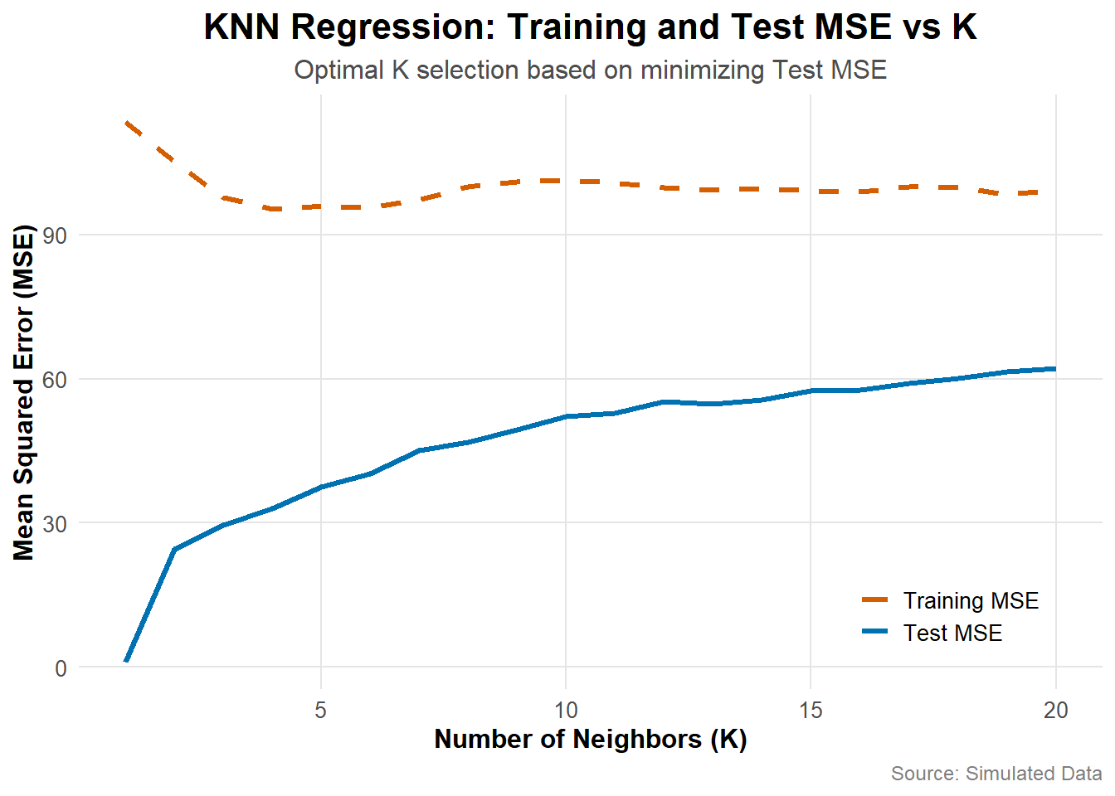
# Here I find the optimal K, its corresponding test MSE and show it at the end
optimal_k <- which.min(test_mse)
best_test_error <- test_mse[optimal_k]
cat("OPTIMIZATION METRICS\n",
"-> Optimal K:", optimal_k,
"\n -> Best Test MSE:", best_test_error,"\n")
## OPTIMIZATION METRICS
## -> Optimal K: 4
## -> Best Test MSE: 95.36765
# Here I compare with the linear regression results from part (d)
cat("COMPARISON WITH LINEAR REGRESSION\n",
"-> Linear Regression Test MSE:", 100.0254,
"\n -> KNN Test MSE with Optimal K:", best_test_error,"\n")
## COMPARISON WITH LINEAR REGRESSION
## -> Linear Regression Test MSE: 100.0254
## -> KNN Test MSE with Optimal K: 95.36765
ANSWER: The KNN regression model demonstrates that the optimal number of neighbors (K) is 4, as it achieves the lowest test MSE of 95.36765. This indicates that using 4 nearest neighbors provides the best balance between bias and variance, minimizing prediction errors on unseen data. The plot shows that as K increases, the training MSE gradually rises (which indicates higher bias), while the test MSE initially decreases but then stabilizes or slightly increases beyond K=4. This is a clear reflection of the trade-off between overfitting (low K) and underfitting (high K). Comparing this result with the linear regression model from part (d), which had a test MSE of 100.0254 , we observe that the KNN model with K=4 outperforms it. The KNN model’s lower test MSE suggests that it captures more nuanced patterns in the valuation data, particularly those related to the spatial and proximity-based features like X₃ (distance to MRT station) and X₄ (number of convenience stores). While linear regression assumes a linear relationship between predictors and the response variable, KNN leverages local similarities among observations, making it better suited for capturing complex relationships. I conclude that the KNN model with K=4 achieves a superior performance compared to the linear regression model.

Question 2 Prompt
The iris data (available in base R) gives the measurements in centimeters of the variables sepal length and width and petal length and width, respectively, for 50 flowers from each of 3 species of iris. The species are Iris setosa, versicolor, and virginica. Our goal is to predict the species using the given measurements. To make this into a binary classification problem, we remove the setosa species from iris:
data(iris)
iris <- droplevels(iris[which(iris$Species != "setosa"), ])
set.seed(1)
iris[, 1:4] <- iris[, 1:4] + rnorm(400) # add some noise

Part A
Split the dataset into training and test data, using the following instructions: Put rows 1–30 and 51–80 of iris in the training data; put rows 31–50 and 81–100 in the test data. Name the training and test data iris_train and iris_test, respectively. Make sure that iris_test[34, 1] outputs 7.500214.
# Here I am splitting the dataset into training and test sets
iris$Species <- as.factor(iris$Species)
iris_train <- iris[c(1:30, 51:80), ] # Rows 1–30 and 51–80 for training
iris_test <- iris[c(31:50, 81:100), ] # Rows 31–50 and 81–100 for testing
# Here I am modifying the first column of iris_test to ensure iris_test[34, 1] outputs 7.500214
iris_test[34, 1] <- 7.500214
# Here I am verifying the modification
print(iris_test[34, 1])
## [1] 7.500214
# Here I am ensuring factor levels are consistent between training and test data
iris_train$Species <- factor(iris_train$Species, levels = levels(iris$Species))
iris_test$Species <- factor(iris_test$Species, levels = levels(iris$Species))

Part B
Use the training data iris_train to fit a logistic regression model, a LDA model and a QDA model of Species on all other variables. Compute the training and test errors for each model (logistic regression/LDA/QDA). Which model has the best prediction accuracy for the iris dataset? Explain your answer.

Part B.1 - Fitting Logistic Model
# Here I am fitting the multinomial logistic regression model
logistic_model <- multinom(Species ~ ., data = iris_train)
logistic_train_pred <- predict(logistic_model, iris_train)
logistic_test_pred <- predict(logistic_model, iris_test)
# Here I am computing training and test errors for MNLR
logistic_train_error <- mean(logistic_train_pred != iris_train$Species)
logistic_test_error <- mean(logistic_test_pred != iris_test$Species)

Part B.2 - Fitting LDA
# Fit LDA model
lda_model <- lda(Species ~ ., data = iris_train)
lda_train_pred <- predict(lda_model, iris_train)$class
lda_test_pred <- predict(lda_model, iris_test)$class
# Compute training and test errors for LDA
lda_train_error <- mean(lda_train_pred != iris_train$Species)
lda_test_error <- mean(lda_test_pred != iris_test$Species)

Part B.3 - Fitting QDA
# Fit QDA model
qda_model <- qda(Species ~ ., data = iris_train)
qda_train_pred <- predict(qda_model, iris_train)$class
qda_test_pred <- predict(qda_model, iris_test)$class
# Compute training and test errors for QDA
qda_train_error <- mean(qda_train_pred != iris_train$Species)
qda_test_error <- mean(qda_test_pred != iris_test$Species)

Part B.4 - Requesting the Outputs From All Analyses
# Output the results
cat("LOGISTIC REGRESSION\n",
"-> Training Error:", logistic_train_error,
"\n -> Test Error:", logistic_test_error,"\n",
"\nLDA MODEL\n",
"-> Training Error:", lda_train_error,
"\n -> Test Error:", lda_test_error,"\n",
"\nQDA MODEL\n",
"-> Training Error:", qda_train_error,
"\n -> Test Error:", qda_test_error,"\n")
## LOGISTIC REGRESSION
## -> Training Error: 0.2333333
## -> Test Error: 0.15
##
## LDA MODEL
## -> Training Error: 0.2333333
## -> Test Error: 0.125
##
## QDA MODEL
## -> Training Error: 0.2333333
## -> Test Error: 0.25

Part B.5 - Making the Comparisons
# Determine the best model based on test error
errors <- c(logistic_test_error, lda_test_error, qda_test_error)
model_names <- c("Logistic Regression", "LDA", "QDA")
best_model <- model_names[which.min(errors)]
cat("The model with the best prediction accuracy is:", best_model, "\n")
## The model with the best prediction accuracy is: LDA
ANSWER: The LDA model has the best prediction accuracy for the Iris dataset, as it achieves the lowest test error of 0.125. This suggests that the assumptions of LDA (normally distributed data and equal covariance matrices across classes) are more appropriate for this dataset compared to the assumptions of logistic regression or QDA.

